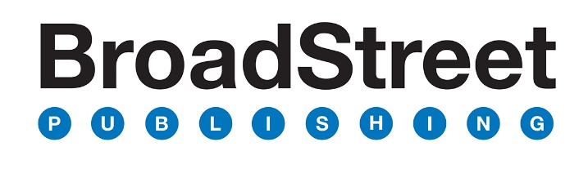

Dear prospective BSP author,

Please read this document and answer the questions contained within as completely as possible.

The purpose of this document is to define the sales opportunity for your book.
- Sections 1–7 help us learn more about you, your book, and your audience.
- Sections 8 and 9 help us determine the sales potential for this project.
*Proposals that do not include a completed sales worksheet will not be considered for acquisition.

We believe the message God has given you is worth hearing and therefore worth wise planning.

Kindly send the completed Word document to proposals@broadstreetpublishing.com.This exercise will make a significant difference in the quality of your book and the quantity of your sales.

Sincerely,

BSP Acquisitions Team

Please fill in the shaded boxes below.

1. Title options that are positive and provide an attractive, memorable hook.

2. Subtitle options that offer a promise or primary benefit to the reader.

3. Engaging sales copy. Create your own book description using the exercises below:

- Short, attention-getting headline. Provide a short, engaging header statement that captures a primary message of the book and gets a purchaser’s attention (2–8 words).

- The problem or felt need. State the problem the book addresses so readers recognize an issue they or someone they know have and their immediate need for the book. For biographies, include an appealing synopsis of the story and why that story should matter to the reader (3-7 sentences).

- Value statements/key selling points. Create 3–5 statements that share the key promises of the book (solutions to problems, what readers will learn, how they will benefit, why the book is for a reader or someone they know, etc.).

- Hopeful closer. Provide a hopeful closing statement for the reader to see the end result of reading your book (1–2 sentences).

4. Table of contents
Please list potential chapters with creative titles (next to the numbers) and a short description (one or two sentences) of the content in each chapter (next to the bullet underneath).

5. Book format
- Projected number of words:
- Desired page count:
- Format (paperback, hardcover, faux leather):

6. Audience
Who is the primary audience for your book? Be specific. Who will be the most interested in your book? Also list a secondary audience.
- (primary)
- (secondary)

List the title and author of three comparable books in the market:

7. Your author bio
  - Short bio (40-60 words):

  - Optional: Long bio (whatever length you want)

8. Current author platform information
Please provide specific details about:
- any previous books you have written and published (include sales numbers)

- your current platform, including social media following, email list, subscriptions, etc.

- your speaking events in the last 12 months, including the number of attendees

9. Complete the Author Sales Estimates worksheet on the last page to identify strategic publishing partners/influencers and quantify sales projections.
*Proposals that do not include a completed sales worksheet will not be considered for acquisition.

Please list all publishing partners and influencers who may endorse, purchase, promote, and/or invite. Quantify each opportunity or commitment numerically. Consider these questions:

1. Who will endorse?
- On the cover, inside the book, and/or in marketing materials
2. Who will purchase?
- For a resource (ministry, education, church, business, media)
- For a store (church, ministry, organization)
- For donors (as a gift)
- For a special event
3. Who will promote you and your book and how?
- To their email list
- To their followers on blogs and social media platforms
- In their store
- In their magazine/newsletter
- At their church
- In their business
4. Who will invite you?
- To keynote or speak at an event
- To do a media interview

SAMPLE ENTRIES
ORGANIZATION / PERSON | DESCRIPTION OF SUPPORT | BOOKS SOLD  (Account for 10,000)
Global Vision | They want to purchase 500 copies at a discount to give to their top donors. They will also put the book on their website as a resource and make it a recommended resource on their monthly email mailing out to 750,000 people. | 500 guaranteed  Website traffic reaches 65k unique visitors/month  Email list of 750k. 41% open rate.
Covenant Conference | They host a conference every year with about 1,000 in attendance. I will be a featured speaker. They agreed to purchase as a discount and put a free copy in their gift bag for the participants. They also want to start a Bible study using the book as a resource. | Estimate 1,000 copies purchase for conference attendees’ gift bag  Bible study averages 25 people per session
Joe Famous | Joe will send out a picture meme of my book when published and will also write an endorsement | 400k Twitter followers  250k Instagram  219k Facebook

Author Sales Estimates

ORGANIZATION / SUPPORTER | DESCRIPTION OF SUPPORT | BOOKS

